# How to create a Pivot Table in Excel 2013 from PlanningFactory CSV File

If you use PlanningFactory as Cloud Solution, you can easy download all data for using in Pivot Tables, his document describes how to do this.

## Download the CSV File you need

Standard:

[https://saxess2.planning-factory.com/csv/NumericValues/[Clustername]](https://saxess2.planning-factory.com/csv/NumericValues/%5bClustername%5d) – for all Numeric Values

Special business types with filtering and sign adjustment

[https://saxess2.planning-factory.com/csv/CashValues/[Clustername]](https://saxess2.planning-factory.com/csv/CashValues/%5bClustername%5d) – only CashValues with adjusted signs

[https://saxess2.planning-factory.com/csv/Profit/[Clustername]](https://saxess2.planning-factory.com/csv/Profit/%5bClustername%5d) – only Profit Values with adjusted signs

[https://saxess2.planning-factory.com/csv/Balance/[Clustername]](https://saxess2.planning-factory.com/csv/Balance/%5bClustername%5d) – only Balance Values with adjusted signs

[https://saxess2.planning-factory.com/csv/TextValues/[Clustername]](https://saxess2.planning-factory.com/csv/TextValues/%5bClustername%5d) – only textual values (events..)

Save it on any place on your computer or network drive

## Start Excel and go to the tab „Data“, select „From Text“

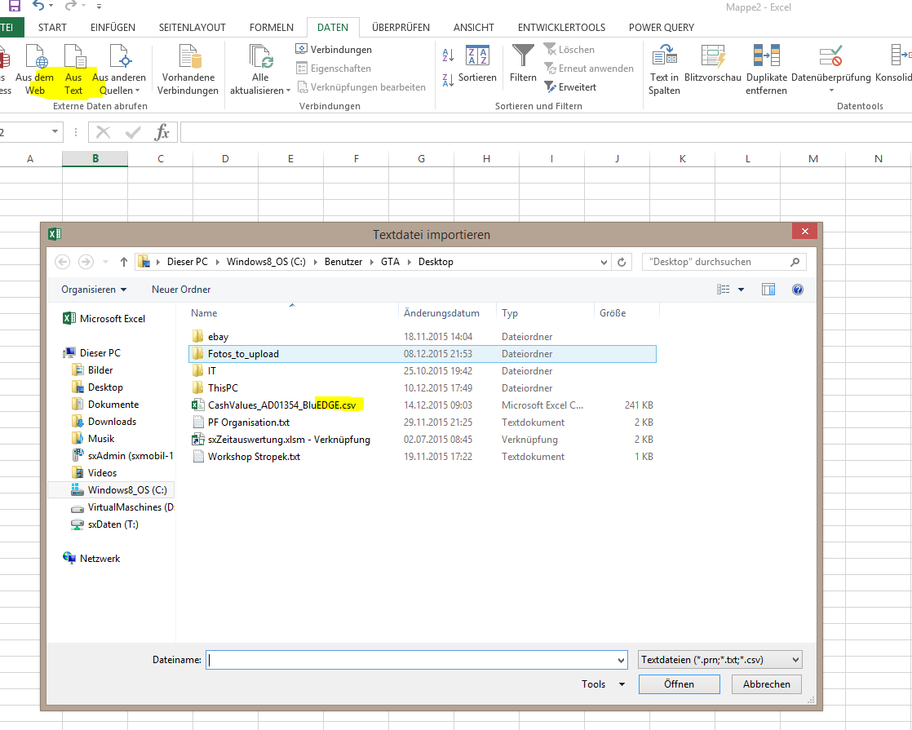

Select the CSV File you did download

## Select „separated“, select Unicode UTF-8 and activate column headers

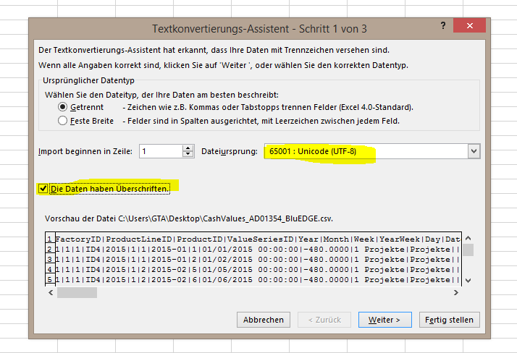

## Set the delimiter Pipe (AltGr + <), unselect „Tabstop“

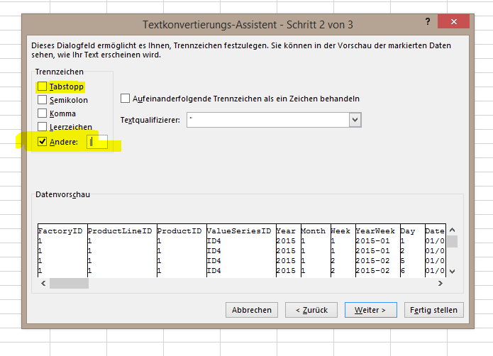

## Set the english encoding of you use a non english Excel

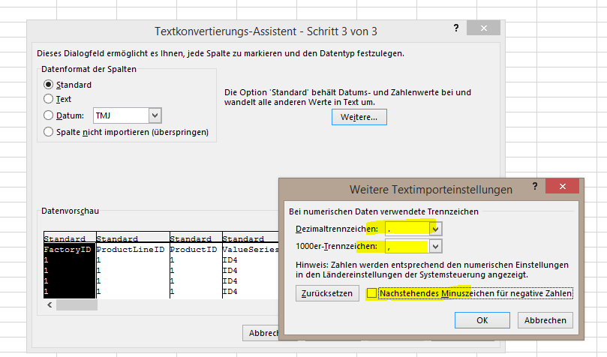

Point for Decimal, Komma für Thousand Separator

## Add the data to the DataModel and select Pivot Table

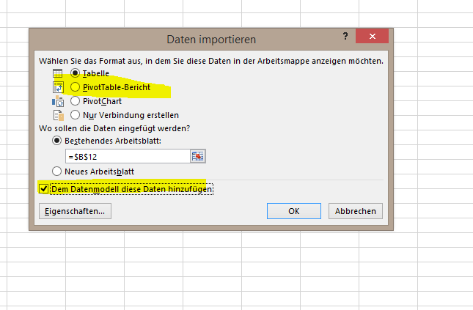

## To refresh the data later, download the new CSV File and click on refresh inside your pivot table.